**Lab 09 – Assignment**

Consider the following given image where (a) presents the original image. You need to apply morphological analysis as describe in (B) option to produce the image (b).

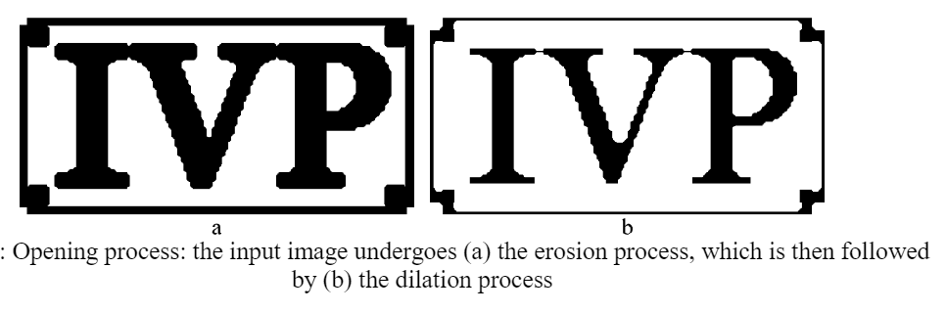

Similarly, you need to apply the closing process as well as describe below.

**Submit the Jupyter Notebook file including code and images.**